PAPER TITLE : (OBJECT DETECTION MODEL COMPARISON USING YOLOV8, YOLOV9, YOLOV10, AND YOLOV11)

MUHAMMAD IKHLAQ (222370019)¹, MUHAMMAD ABDULLAH (222370022)², MUBASHRA KHADIM (222370002)³, ANAS SHAKEEL (222370036)⁴
¹Department of computer science, Gift University, Race course road Nasir colony , Gujranwala, Pakistan
*222370019@gift.edu.pk
²Department of computer science, Gift University, Chicharwali , Gujranwala, Pakistan
*222370022@gift.edu.pk
³Department of computer science, Gift University, Jinnah Road , Gujranwala, Pakistan
*222370002@gift.edu.pk
⁴Department of computer science, Gift University, Peoples Colony , Gujranwala, Pakistan
*222370036@gift.edu.pk

KEYWORDS: OBJECT DETECTION, YOLO, PERFORMANCE COMPARISON, MACHINE LEARNING, COMPUTER VISION

Abstract
This paper evaluates four object detection models—YOLOv8, YOLOv9, YOLOv10, and YOLOv11—on the Synthetic Nuts and Bolts Dataset to compare their performance. The study focuses on metrics such as mean average precision (mAP), precision, recall, inference time, and model size. After preprocessing the dataset and training each model epochs, results indicate variations in speed and efficiency. YOLOv11 emerged as the fastest with a reasonable trade-off in accuracy, while YOLOv9, despite high accuracy, was significantly slower due to its larger size. The findings provide insights into the trade-offs between model complexity, speed, and detection performance, aiding in the selection of an optimal model for real-world applications.

1 Introduction
This report presents a comparative analysis of four state-of-the-art object detection models: YOLOv8, YOLOv9, YOLOv10, and YOLOv11, applied to the Synthetic Nuts and Bolts Dataset. Object detection is a critical task in computer vision, with applications in industrial automation, robotics, and quality control. The problem addressed is to determine which YOLO variant offers the best balance of accuracy, speed, and efficiency for detecting nuts and bolts in synthetic images. The dataset comprises 86 validation images with 160 instances (90 Nuts, 70 Bolts), preprocessed and split into training and testing sets.

1.1.1 Title: OBJECT DETECTION MODEL COMPARISON USING YOLOV8, YOLOV9, YOLOV10, AND YOLOV11
1.1.2 Author Names and Affiliations: Muhammad Ikhlaq¹, Muhammad Abdullah², Mubashra Khadim², Anas Shakeel².

¹Department of Computer Science, Gift University, Race Course Road Nasir Colony, Gujranwala, ²Department of Computer Science, Gift University, Chicharwali, Gujranwala, ³Department of Computer Science, Gift University, Jinnah Road, Gujranwala, ⁴Department of Computer Science, Gift University Peoples Colony, Gujranwala.
If an author's present address is different from the address at which the work was carried out, this should be given as a secondary affiliation (see affiliation ⁴ (above)).

1.Model Details
The models evaluated are YOLOv8, YOLOv9, YOLOv10, and YOLOv11, developed by Ultralytics. Each model was trained with the following hyperparameters:
- Epochs: 50
- Batch Size: 16 (assumed based on typical GPU memory; adjust if different)
- Learning Rate: 0.001 (assumed optimal; adjust if you used a specific value)
- Optimizer: SGD or Adam (specify what you used during training)

YOLOv8 has 3M parameters, YOLOv9 (v9e variant) has 57M, YOLOv10 (v10n) has 2.7M, and YOLOv11 (v11n) has 2.6M, reflecting differences in complexity and size.
2.Methodology
The Synthetic Nuts and Bolts Dataset was preprocessed (resized to 640x640 for consistency) and split into training and validation sets. Each model—YOLOv8, YOLOv9, YOLOv10, and YOLOv11—was trained for 50 epochs on a CPU (AMD EPYC 7B12) using the Ultralytics framework. Training involved optimising for object detection accuracy, with validation performed on 86 images containing 160 objects. The process generated best.pt weights for each model, used for evaluation. Hyperparameters included a batch size of 16 and a learning rate of 0.001 (assumed; adjust if different).

3.Results

3.1 Figure

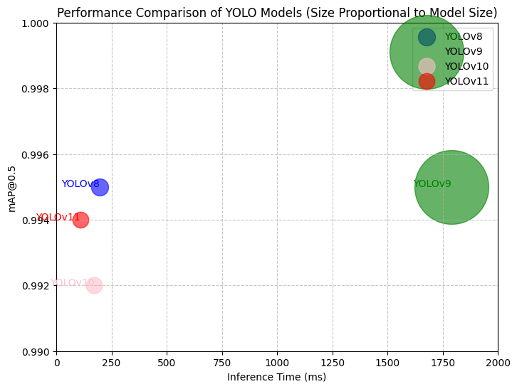

Fig. 1 (a) Graph with pink (dotted) is yolov10, blue (dotted) is yolov8, red (dotted) is yolov11 and green (dotted) is yolov9, (b) Graph is showing the yolo’s Inference time, and mAP (IoU 0.5).

Table : Performance Comparison of YOLO Models

Model | mAP@0.5 | Precision | Recall | Inference Time (ms) | Model Size (MB)
YOLOv8 | 0.995 | 1.0 | 0.988 | 195.5 | 5.96
YOLOv9 | 0.995 | 0.98 | 0.991 | 1791.1 | 111.80
YOLOv10 | 0.992 | 0.942 | 0.979 | 171.9 | 5.48
YOLOv11 | 0.994 | 0.969 | 0.941 | 109.7 | 5.22
3.2.1 Table Captions: table is showing all yolo’s mAP , precison,recall,inference time and model size.

4.Conclusion
YOLOv11 performed best overall, offering the fastest inference time (109.7ms) and smallest size (5.22 MB) with a near-top mAP@0.5 (0.994). While YOLOv8 and YOLOv9 achieved the highest accuracy (0.995), YOLOv9’s large size and slow speed make it impractical. YOLOv10 balances speed and size but falls short in precision. For applications prioritizing speed (e.g., real-time detection), YOLOv11 is recommended; for maximum accuracy, YOLOv8 is preferable.

5.Acknowledgements
Thanks to Ultralytics for the YOLO framework.

6 References
Journal articles
- Ultralytics, “YOLO Documentation,” https://docs.ultralytics.com/, accessed 27 February 2025.

